Jefferson Hills Recreational Initiative
2nd ^{t} Annual Golf Outing
Play golf, have fun, and support our Initiative’s efforts
Friday September 9, 2016
*8:30AM Registration *9:30AM Shotgun Start*

Victory Hills (formerly 7-Springs) Golf Course
357 Pineview Drive
Elizabeth, PA 15037

Prizes for 1st/2nd/3rd/Last
Closest to the Pins,
Longest Drive & plenty of Raffles

$100 each/$400 per 4-some
Includes 18 holes, Cart and Dinner

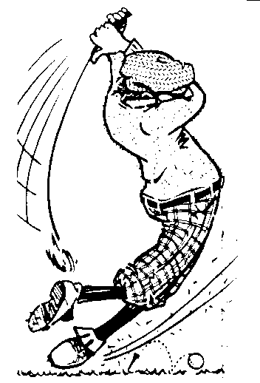
*Corporate Sponsors – Tee Signs & Donations for Raffle Prizes are also available & appreciated*

For More Info Contact:
Brian Konick (412-638-7540, briankonick@gmail.com)
Dave Reinhart (412-973-3217, dreinhart@adventcom.com)
Tom Bucy (412-965-5907, tbucy20@comcast.net)
Bill O’Brien (412-527-9573, wobrien3055@comcast.net)
BJ Pugh (412-901-7330, pughbj20@verizon.net)
www.jeffersonhillsrecinitiative.com

